**Software Engineering Proposal**



**Sparing.an**

**An Android Based Application for Finding Partner in Sports**

**Arranged by:**

Gilang Yudharaka 1606825266 2016

Mahdi Yusuf 1606825341 2016

Michael Wijaya 1606883543 2016

**Computer Engineering**

**Faculty of Engineering**

**University of Indonesia**

**DEPOK**

**2018**

# **FOREWORD**

We praise and gratitude to God., so that we could complete this first project documentation well. Although we meet obstacles by many things, but we are grateful that we stillbe able to write this project documentation.

The basics of programming is very important, which is needed before developing things in software and computer hardware. By programming, we are trained to be able to think logically,systematically, but also creative. Nowadays, so many unique applications that really help human todo anything faster and more efficient.

As a student of Computer Engineering, the authors wanted to have superior capabilities and contribute by make a project. As first step, and also to fulfill the task of this documentation, theauthors will try to make a project about partners finder in sports and hope it will be efficient, easy to use, and highly useful. We also thanked to Prof. Dr. Ir. Riri Fitri Sari, M.Sc.,MM. and Ruki Harwahyu S.T., M.T. who has been guiding for learning and assist the preparation of this project documentation.

This final documentation is still very far from perfect therefore the authors is expecting criticism and suggestions to improve this work to be implemented better. Finally, the authors hopethis article can be useful for readers.

Regards,

Development Team

# **TABLE OF CONTENTS**

**FOREWORD** 2

**TABLE OF CONTENTS** 3

**1.** **INTRODUCTION** 5

**1.1.** **Background** 5

**1.2.** **Purpose** 5

**1.3.** **Target** 5

**1.4.** **Hardware Requirements** 6

**1.5.** **Market Opportunities** 6

**1.6.** **Analysis of Risk** 7

**2.** **PROJECT MANAGEMENT** 9

**2.1.** **Review of System** 9

**2.2.** **Project Management** 9

**3.** **DESIGN DIAGRAMS** 12

**3.1.** **Use Case Diagrams** 12

**3.2.** **Diagrams** 13

**3.3.** **Diagrams** 14

**3.4.** **Diagrams** 15

CHAPTER 1 | INTRODUCTION

# **INTRODUCTION**

## **Background**

In Jakarta, most people have full-time activities from day to day, starting as early as 6 in the morning, until 7 in the evening. This cycle goes on 5 days a week for most people, and some even got 6 days a week working until Saturday. They got so busy until they forgot to exercise in other to maintain their physical health. Meanwhile, some may already realize the importance of exercising by doing sports, but in doing so, they need partners as well as opponents to do some sports together. For this reason, we will create an Android-based application called “Sparing.an” which enables people to meet and do sports together.

## **Purpose**

The main purpose of Sparing.an is to be a platform to help people find partners as well as opponents in sport. There are lots of people who would like to do sports in their free time, but having a difficult time finding opponents or partners in their sports activities. This application is expected to solve this problem. Each user will determine their schedule, and this application will find partner or opponents that matches the user’s schedule. In addition, the existence of this application will help not only sport lovers but also helping people socializing in real world.

## **Target**

The target of Sparing.an is everyone who have smartphone and internet connectivity that typically love sport but having trouble finding partners as well as opponents, people who would like to find new friends doing their favourite sport, or a team who would like to get some new experience and develop their skills by challenging other teams near their location.

1. Determinant of Project Success

* Project runs based on schedule.
* Group members have good time management to work on projects.
* Project implementation that meets expectations.

1. Expected Benefit

* Make an application that helps user to find opponent or partner in Sports
* Sparing.an becomes platform that will help people to develop their skill in sports with finding new sparring partner.
* Sparing.an becomes an application that grows Indonesian’s interest in Sport.
* Creating a new generation of young athletes in Indonesia.
* Makes people socializing not only in digital world but also in the real world.

## **Hardware Requirements**

1. PC with minimum specification:

* 3 GB RAM.
* 20 GB of available disk space.
* 1280 x 800 of screen resolution.

1. Android 4. 0 (KitKat) + based Smartphone.
2. Software for Development:

* Android Studio for the Android Software Development.

## **Market Opportunities**

Market opportunities for this application are very broad. Sport is an activity that can be done by everyone. There is no age limit for doing sports. Based on that fact, this current topic is excellent for exploitation. Sparing.an is an Android-based application, which is quoted from et.co.id that Android users in Indonesia reach 79.87%. The following are data compiled by et.co.id :

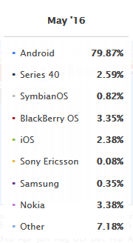

Picture 1. Mobile User Operating System Statistics

With these data, Sparing.an can be present in the community and has a huge opportunity.

## **Analysis of Risk**

1. Experience problem

There is a bunch of feature that our team make for this application. The need of this project is the understanding of java language, database, and UI/UX design. We also have to integrate this application to the internet.

1. Time management problem

There a lot of things that we should study about, also we have 2 lab sessions with lots of work to do. Besides that, we also have another project from other classes that also have to be done. The time management is important to make this project success.

1. Application promotion

This application will give the best experience if this app has lots of users. Therefore, it is necessary to conduct promotions and dissemination of information about Sparing.an so that people able to know and use this application.

CHAPTER 2 | PROJECT MANAGEMENT

# **PROJECT MANAGEMENT**

## **Review of System**

The working of Sparing.an are the application that will find partners or opponents in sport based on the user’s designated schedule. Sparing.an has a feature where every user will have their own rating that given by another user based on their experience partnering with. This application is also support user to make team if they want to do a team sport, such as basketball, football, futsal, or badminton.

The work flow of Sparing.an:

* Every user signup for Sparing.an. Every user has to submit their data such as gender, age, and their location.
* After user complete the registration, user have to choose their sport, and start to make a schedule if they have planned to do sport.
* Our system will give you list about every user that have the same schedule as yours. This list that the system gives you is based on schedule and location. Each user is able to chat within the Sparing.an chat service to determine the location.
* After doing sport with Sparing.an partner, every user has to do the review form to scoring the partner.

## **Project Management**

1. Roles Assignment

|  |  |  |
| --- | --- | --- |
| Name | Role | Description |
| Gilang Yudharaka | Programmer | Programmer for Android Apps |
| Mahdi Yusuf | Programmer | Programmer for Android Apps |
| Michael Wijaya | UI/UX Designer | Programmer for User Experience and User Interface |

1. Collaboratives Tools

There are some collaborative tools that we use in this project:

* Trello : collaboration application to complete a group project. The division of tasks can be done with this application using a kind of list-to-do on the project board. With this application, all tasks can be monitored by each group member.
* Google docs: A web application to make a collaborative document.
* LINE: application that our group will use for communicating.

1. Weekly Meeting

Weekly meetings will be held depends on the availability of the group members. Meetings can be done directly or online. This weekly meeting will be held to discuss the progress and to discuss the next objective that will be completed.

1. Project Timeline

|  |  |  |  |  |  |  |  |  |  |  |  |  |  |  |  |  |  |
| --- | --- | --- | --- | --- | --- | --- | --- | --- | --- | --- | --- | --- | --- | --- | --- | --- | --- |
| Month | September | | | | October | | | | November | | | | December | | | | PIC |
| Brainstorming Idea |  | | | |  |  |  |  |  |  |  |  |  |  |  |  | GY |
| Req. Analysis & UML Design |  |  |  |  | |  |  |  |  |  |  |  |  |  |  |  | MY |
| Learn Programming the Apps |  |  |  |  |  | | | |  |  |  |  |  |  |  |  | MW |
| Prototyping |  |  |  |  |  |  |  | | | |  |  |  |  |  |  | GY |
| Unit Testing |  |  |  |  |  |  |  |  |  |  | |  |  |  |  |  | MW |
| Finishing |  |  |  |  |  |  |  |  |  |  |  | |  |  |  |  | MY |
| User Testing |  |  |  |  |  |  |  |  |  |  |  |  | |  |  |  | GY |
| Presentation |  |  |  |  |  |  |  |  |  |  |  |  |  |  |  |  | MW |
| Project Documentation |  |  | | | | | | | | | | | | |  | | MY |

CHAPTER 3 | DESIGN DIAGRAMS

# **DESIGN DIAGRAMS**

This chapter shows UML Diagrams (Use-Case, Activity and Class Diagram). UML used for explain the system by 4 views (requeirements, logical, dynamic, physical views) and it’s controlled by an independent standards body called by Object Management Group.

## **Use Case Diagrams**

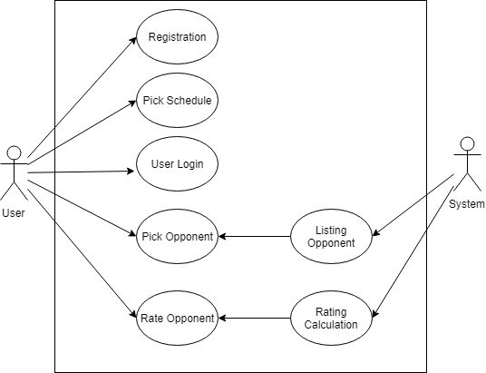

## **Sequence Overview Diagrams**

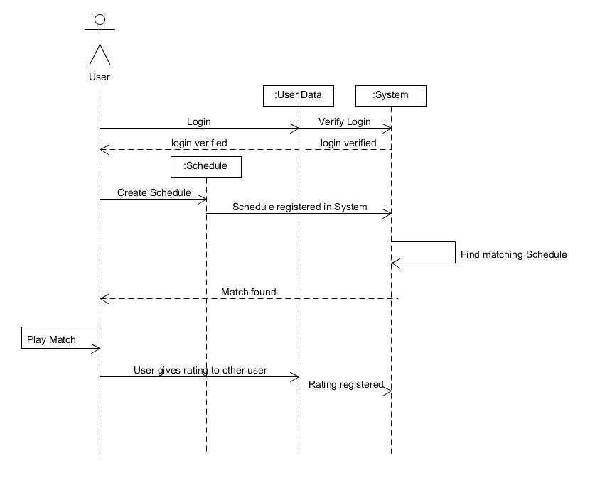

## **State Diagrams**

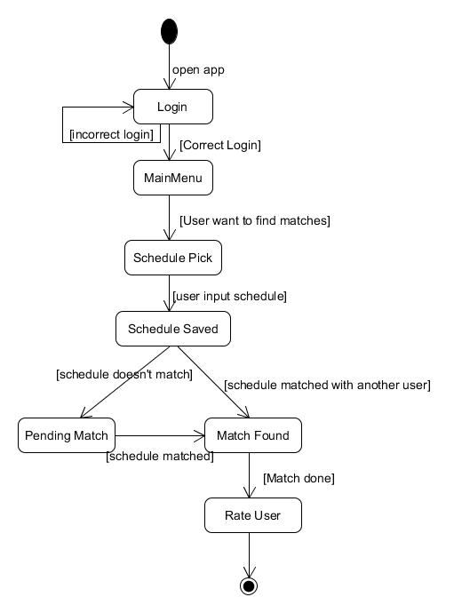

## **Activity Diagrams**

